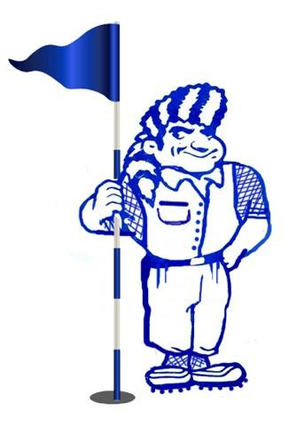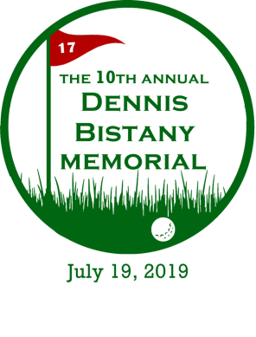 **MAIC/MHS Boosters**

**PO Box 2229**

**Methuen, MA 01844**

To Whom It May Concern,

I am sending this letter on behalf of the Dennis Bistany Memorial Fund and the Methuen Athletic Improvement Committee (MAIC)/Methuen High School Boosters.

Dennis Bistany, whose life ended too short due to a tragic drowning, was a well-liked and respected middle school teacher at the Marsh Grammar School in Methuen and a member of the MHS Baseball coaching staff. Dennis loved kids and spent much of his time on the field coaching baseball. He coached various teams throughout his life including at Fisher College. But perhaps one of his proudest moments came when he was the head coach of the Salem, NH Little League All-Stars who went on to win the World Series Championship in 1997.

The MAIC/ MHS Boosters are a non-profit organization established to provide student athletes with various events to celebrate individual & team accomplishments. The MAIC/MHS Boosters believe in the investment of our children through scholarship and athletics and because of this belief over $100K has been donated back to the children.

To honor Dennis and his love for kids and sports, the Dennis Bistany Memorial Fund has partnered with the MAIC/ MHS Boosters to deliver the Dennis Bistany Memorial Golf Tournament. Proceeds from this event will benefit the Dennis Bistany Scholarship Fund & MAIC/MHS Boosters mission.

We invite you to be a part of the 10th annual Dennis Bistany Golf Tournament by becoming a sponsor. We have different levels of sponsorships available. The enclosed flyer lists the sponsorship program in detail. If a sponsorship is not in your budget, we would welcome any monetary or raffle donation.

Thank you in advance for your time and consideration. If you have any questions feel free to contact a member of the fundraising committee:

Bill Bryant: [bbryant22@comcast.net](mailto:bbryant22@comcast.net) or 978-609-6199

Pam Bryant: [pamb300@comcast.net](mailto:pamb300@comcast.net) or 978-702-6095

Lorraine Anthony: [lorraineis2@comcast.net](mailto:lorraineis2@comcast.net) or 978-760-0187

Sincerely,

MAIC/MHS Boosters Golf Tournament Committee

TAX ID Number: 46-3674342